Tayleur Hylton

Midterm Proposal

Personal Website

Blog Post: https://tayleurwebdev.tumblr.com/

The concept of my website is a personal resume. I am graduating in May and I think it will be useful to showcase my work on a website I that created by myself. I am in Gallatin and my concentration is a mix of marketing and sociology. I am also finishing the IDM major this semester. I want the website to take visitors through the skills I have learned over the past 4 years. The introduction page is a video of a google search, leading to an about me and options to continue through the site. There’s a resume button, a photography button and an essays button. The first official page is my resume. The second page is my photography portfolio with the best images I took in my photography class last year. The last (for now) will be a list of my essays in the format of a google search. The links will lead to pdfs. There will be navigation bar at the top to showcase the categories and suggested topics/pages in a sidebar navigation with pictures.

Inspiration Pinterest Mood Board: <https://www.pinterest.com/tayleurhylton/personal-website-inspiration/>

Inspiration Websites:

<http://julia.na/>

<http://www.garylemasson.com/>

Site Map: <file:///C:/Users/Tayleur%20Hylton/Documents/personal%20website%20layout.pdf>

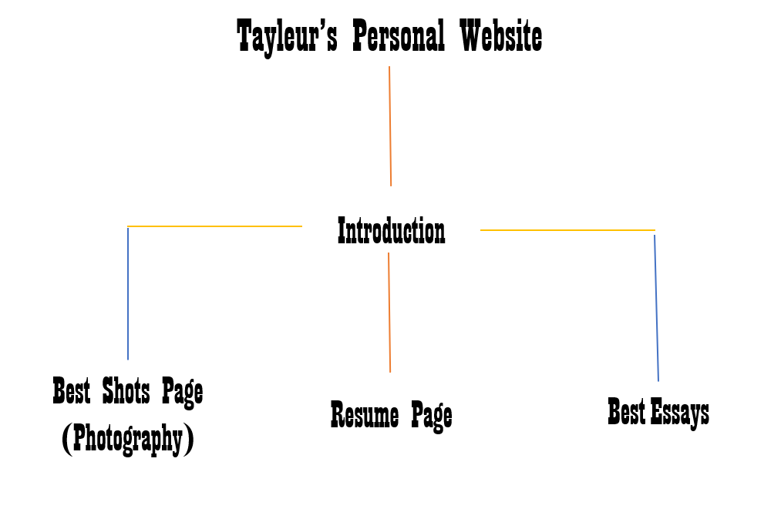

Wire Frame:

<https://wireframe.cc/pro/pp/689e0e32c144449>

**concepts|skills we have covered that you will use to build your site**

We have learned to insert images and change their colors and rotation. This will help with the

layout. We have learned how to organize information architecture and create site maps which will help me sketch out where everything on the site needs link to and be placed. We learned how to implement a navigation bar on the top of the screen. We also learn how to place our navigation words in blocks to allow them to be easily clicked. Especially helpful, will be the side navigation with pictures that we learned how to do in class. This will allow me to make a suggestions bar and keep users going through the site. Also, learning how to use H1, H2 etc to organize text and headings will be helpful and using the <p> will allow me to insert text when necessary.

**concepts|skills you need to still learn to complete the project**

I need to learn to to insert cool shapes and how to format text around objects on a page that are not just horizontal or vertical. I need to learn how to make my website answer questions about me in a video format, similar to this example: <http://www.garylemasson.com/>